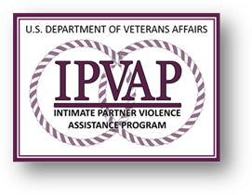

## **Promoting Relationship health & safety**

## **Check up, check in & check out our resources**

## **DID YOU KNOW?**

# Date: Tuesday October 20th

# Time: 10 am-11:30 am

# Location: WebEx Virtual Meeting Platform

# Meeting Details to Follow

# For more information please contact

# Maritza Rodriguez, LCSW, IPVAP Coordinator

# [Maritza.Rodriguez2@va.gov](mailto:Maritza.Rodriguez2@va.gov) 718-836-6600 Ext. 3749

👉 *VA recommends all women Veterans be screened for intimate partner violence (IPV).*

👉 *Lifetime prevalence of IPV in the Veteran population is 33% versus 7.6% for men and 22.1% for women in the civilian population.*

👉 *29% of randomly surveyed female Veterans currently in relationships have experienced issues related to DV/IPV in the last year.*

👉 *A Veteran’s spouse may be at risk for experiencing IPV with a lifetime prevalence of 13.5% when the Veteran is not experiencing symptoms of PTSD versus 33%-58% when the Veteran is experiencing symptoms of PTSD.*

# *New York VA Health Care Harbor System is hosting*

# *Its 1st Virtual*

# *Domestic Violence/Intimate Partner Violence*

# *Resource Fair*